**VIVEKANANDA INSTITUTE OF PROFESSIONAL STUDIES- TC**

**VSIT**



COURSE: BCA I SEMESTER

SUBJECT: LAB BASED ON WEB TECHNOLOGIES DATE: 4.9.2024

**Lab Assignment 2**

1. Write the HTML code to generate a Web layout. Consider the following constraints while writing the HTML code: Use CSS style in form tag to set CO1
2. the background color of the form to pink and
3. font text size to 30px.

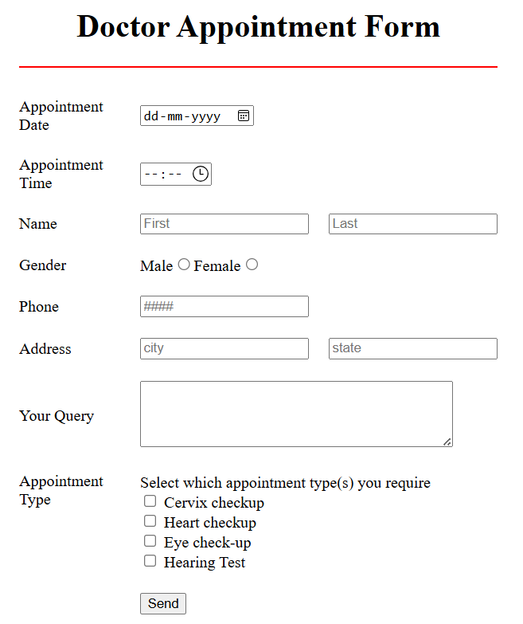

1. Write the HTML code to generate the following webpage: CO1

